**ICIN BANK WRITE UP**

**Project development guidelines:**

**Step – 1:** Open Visual Studio for creation of frontend application

**Step – 2:** Create database in MySQL

**Step – 3:** Open eclipse, create a SpringBoot framework which consist of all the backend logic

**Step – 4:** Write a logic for Registration, Login, Account transaction, Transfers, Saving Details, Profile Settings and Requesting Cheque Book and connect with your application and upload everything in GitHub.

**Step - 5:** Open Amazon EC2 Instance, install the Jenkins, docker and GitHub using SSH Client in the local virtual machine

**Step – 6:** Create an object driver for ChromeDriver and Test the Web Application using Selenium

**Step – 7:** Open Jenkins at localhost:8080, login and configure the job to be done.

**Step – 8:** Open GitHub Repository in the same EC2 Instance and configure it.

**Step – 9:** Build the job in the Jenkins and check the console output

**Step – 10:** Run the program in the server in the localhost

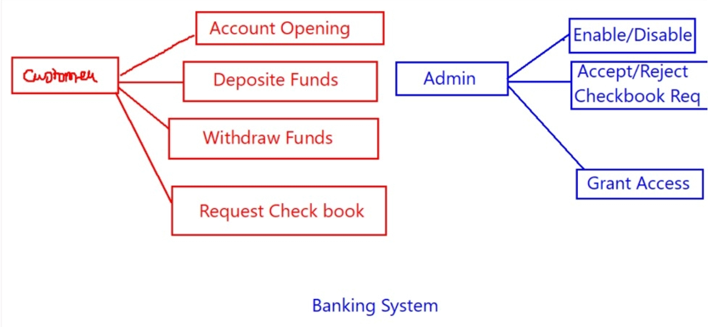**Features**

